This is a document showing how to download GSON and how to use it assuming one has already downloaded and plans to use IntelliJ

Download a jar file of GSON from this site

<https://mvnrepository.com/artifact/com.google.code.gson/gson/2.8.8>

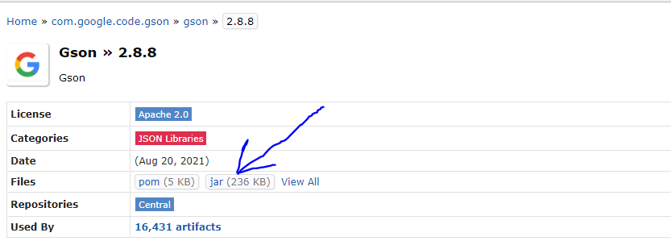

From IntelliJ if you already have the project up. Go to File -> Project Structure to get the following screen

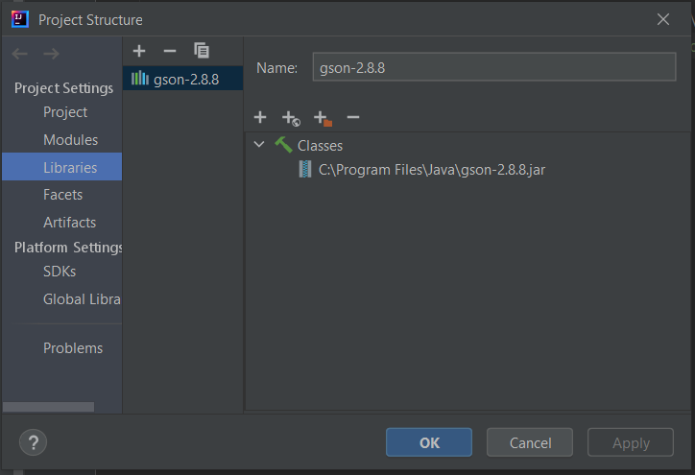

From the screen above go to Project Settings -> Libraries

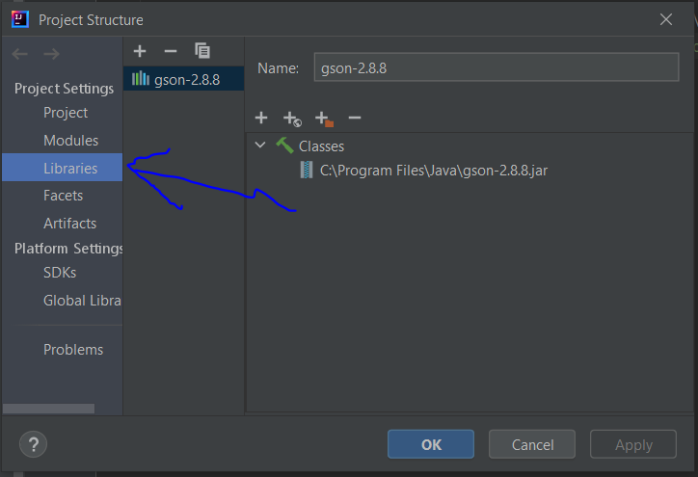

Press on the + and select java

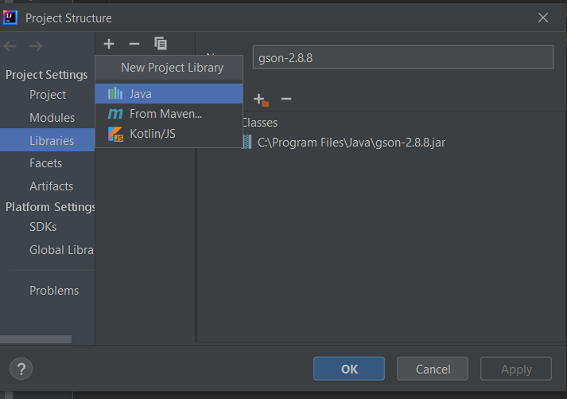

From there select the path that contains the GSON.jar file

Finally, Press Apply and OK

